

Jefferson Award Presented to Stacey Chance
For those who are afraid of flying, airline pilot offers a calming class
Heather Maddan, Chronicle Staff Writer
Sunday, August 13, 2006

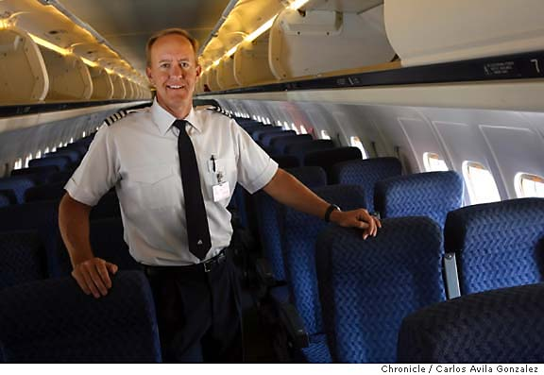
Stacey Chance flew his first solo flight on his 16th birthday. The next day, he went down to the Department of Motor Vehicles and got his license. Now 47, and a commercial pilot for American Airlines since 1985, Chance has always been more comfortable in the air than on the road. In 2001, he put up www.fearofflyinghelp.com, a free online course to help those with aviophobia ease their fears.
At that time, Chance, who grew up watching airplanes take flight at Napa Airport, said he was surprised to learn that "fear of flying" was Googled 3,000 times a month. Because there were many books on the subject, he established the Web site to educate passengers on their biggest concerns -- turbulence, take-offs and in-air panic attacks -- in the hope that they could overcome them.
Enlisting the help and advice of fellow pilots, flight attendants and therapists, Chance put together sections that addressed issues people brought up. He found that people who are claustrophobic, like to be in control and have strong imaginations commonly had problems flying. He also discovered that many women who flew developed a fear of flying once they had children.
Chance started taking flying lessons at 14, earned his Bachelor's of Science in Engineering from San Jose State University and then got a job flying small 10-seater planes in Chico. He currently flies routes in the United States, primarily in the Southwest. His favorite destinations are New Orleans, Las Vegas and San Diego.
In a typical work week he has two to three days on and two to three days off. He spends his free time piloting his private plane, an ultralight two-seater with pontoons so he can make water landings. "I fly high and fast at work, and low and slow on my off time," said Chance, who makes camping trips to Lake Berryessa and around the Delta. He stores his "toy" in a hangar near his home in Discovery Bay, where he docks his ski boat.
Chance also owns a car and says the most dangerous part of a flight is the drive to the airport. "On the ground, you really have to be aware while you are driving with people talking on their cell phones and so many things you can crash into," he said. "Up high, there aren't any obstacles. The plane sails along -- it is relaxing."
For more information, go to www.fearofflyinghelp.com.

Each week, The Chronicle features a Bay Area resident who has won a Jefferson Award for making a difference in his or her community. The awards are administered by the American Institute for Public Service, a national foundation that honors community service. Bay Area residents profiled in The Chronicle are also featured on CBS 5-TV and KCBS-AM, which are Jefferson Award media partners, along with The Chronicle.
E-mail Heather Maddan at hmaddan@sfchronicle.com.

